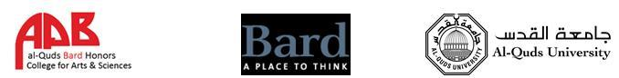

Al Quds Bard College Access/YES Scholarship Application

Full name:

Official ID number: Gender: M or F

Place of birth: Date of birth:

Permanent address:

Phone number:

Email address:

High school name:

High School Average:

Testing (fill any that are applicable):

TOEFL:

SAT I:

SAT II:

Tawjihi:

Please answer each question within this document, directly under the question itself. Take as much space as you need. We want to get a sense of how you think, as well as your writing abilities and English level.

- Tell a story of a topic, a class, a teacher or a book that you have found inspiring during your education to date.

- Describe a moment in your education when you felt challenged or “stuck.” How did you respond to this difficulty?

- How did the ACCESS or YES program change you as a student or individual?

- What are your strengths as a student? What makes you proud that you would like to share with us?

- Where do you feel you need to improve as a student? How will you approach making these improvements?

- Describe any extracurricular activities you have been involved in during the past four years and how they might have affected you.

